|  |
| --- |
| Software Design Specification  **< Car Parking Multi stunt Game >**  Project Code:  CS Regular 9 (CSR9)  Internal Advisor:  External Advisor:  Project Manager:  Sir Saad Razzaq  Project Team:  Team Lead: M Usama Shakoor (BSCSF18M031)  Team Member: Mubeen Saleem (BSCSF18M024)  Submission Date:  January 26, 2022 |

Table of Contents

Document Information 4

Definition of Terms, Acronyms and Abbreviations 4

1.Abstract 5

2.Purpose of Document 5

3.Background and Justification 5

4.Project Methodology 6

5.Project Scope 7

6.High level Project Plan 7

**Key Milestones and Deliverables:** 7

1. 7

2. 7

3. 7

4. 7

5. 7

7.Overall System Description 7

7.1 User characteristics 7

7.2 Operating environment 7

7.3 System constraints 8

8.External Interface Requirements 8

8.1 Hardware Interfaces 8

8.2 Software Interfaces 8

9.Functional Requirements 9

9.1 User/Player profile () 9

9.2 Joining room with another player () 9

9.3 Single/multiplayer room () 9

9.4 Select character like (Male, Female) () 9

9.5 Player Inventory System () 9

9.6 Select vehicle like (Cars, Trucks, Buses etc.) () 9

9.7 Defeat others with strategy () 9

9.8 Compete opponent () 9

9.9 Win/Lose () 9

9.10 Rewards () 9

10.Non-functional Requirements 10

10.1 Performance Requirements 10

10.2 Safety Requirements 10

10.3 Security Requirements 10

10.4 User Documentation 10

11.Use Case Diagram 10

12.Design Considerations 17

12.1 Assumptions and Dependencies 18

12.2 Risks and Volatile Areas 18

13.System Architecture 18

13.1 System Level Architecture 18

13.2 Sub-System / Component / Module Level Architecture 18

13.3 Component / Sub-Module Level Architecture (1…n) 19

14.Design Strategies 19

14.1 Load game 19

14.2 Make profile 19

14.3 Join room/parking system 19

14.4 Game start 20

14.5 Compete with opponent 20

14.6 Win/Lose 20

15.Detailed System Design 20

15.1 Class diagram: 20

15.2 Collaboration Diagram 21

15.3 Entity Relationship Diagram (ERD) 22

15.4 Activity Diagram 22

15.5 Sequence Diagram 23

16.References 25

# Document Information

|  |  |
| --- | --- |
| **Category** | **Information** |
| University | UOS |
| Project | Car Parking Multi Stunt Game |
| Document | Software Design Specification |
| Document Version | 1.0 |
| Identifier |  |
| Status | Draft |
| Author(s) | Team Lead: M Usama Shakoor (BSCSF18M031)  Team Member: Mubeen Saleem (BSCSF18M024) |
| Approver(s) | PM |
| Issue Date | January. 10, 2022 |
| Document Location |  |
| Distribution | 1. Advisor 2. PM 3. Project Office |

# Definition of Terms, Acronyms and Abbreviations

|  |  |
| --- | --- |
| **Term** | **Description** |
| ASP | Active Server Pages |
| DD | Design Specification |
|  |  |
|  |  |
|  |  |
|  |  |
|  |  |
|  |  |
|  |  |

# 

# 1.Abstract

Due to the easy and cheap access of 3G and 4G connectivity, the trend of online games has increased. Covid pandemic also increased in download of games on both pc and mobiles. We have found multiple single user games but we have limited access to multiple player games. Most of the games are paid and require subscription charges.

This multiplayer base game is not just for the people of Pakistan but as well as for all over the world this game will perform a simulator of the vehicle. The game will give you practice in physically driving the vehicle Player will load the game and enter in the main menu scene, where he/she can play and quit the game. When he clicks on play the profile creation starts and gives the other information and joins the room for online racing and clicks on parking to play the game. Player chooses his/her character name according to his/her wish. Players compete with each other. Losers will be punished like their level r coins consumed and the winner will be rewarded with coins.

# 2.Purpose of Document

The purpose of the Software Design Document is to provide a detail description of the design of a software which we created and fully describe to allow for software development to proceed with an understanding of what is to be built and how it is expected to build. The project is going to the Car racing system & parking. In this we will create a different classis which describe their all features in it which can help us on later. This game has different from the other games.in this documents we will use the diagrams, maps to describe our project.

# 3.Background and Justification

There is a short amount of multiplayer strategy games available in App play-store because the working in multiplayer games is very limited. All of these provide the best feature game for the user's entertainment. This game will be provided in the app store as a freeware game. Multiplayer video games are video games in which more than one person can play the same game. During its early history, video games were often single-player-only activities, Multiplayer games allowed players interaction with other individuals in partnership, competition. Multiplayer games typically require players to share the resources of a single game system or use networking technology to play together over a greater distance.

This game will offer a simulator of the vehicle in past their will be only single player games only single player can play the game at a time nowadays the new technology of the internet all the people can play the game at a same time over internet with other peoples. This will be different from the other games because it will include both features offline and online. All the other games will be Offline R online this multiplayer game will have both features. People can play this game very smoothly.

In the past there were two different types of games available in the play store one is car parking and other is car stunt game. But we merge these two features in a single game.

The Names of these two different types of games are as follows that are available in play store.

Car parking 3D: car driving simulator1

Ramp car stunt: crazy car racing games2

# 4.Project Methodology

The main Unity 3D platform will be used for development.

Target platform will also be android users or Android OS.

The programming language will be C#.

Best existing tool is unity 5.6.6.f.2

Visual Studio/Mono-Behavior tool is used for editing the code of C#.

The Diagram Maker tool is used for making the UML Diagrams.

The size of the development effort will be great because high skills are required for this project

These are the Features are performed in this game:

User/Player profile

Joining room with another player

Select character (Like Women, Men)

Select different vehicle (Cars, Trucks)

Defeat others with strategy

Win/Lose

Rewards

# 5.Project Scope

This android game is for all kinds of people. The people who are interested in playing multiplayer games. Android users and attracting them on a single platform which provides opportunity for multiplayer base games. The main features of this game will also provide a training for the people to learn a car driving and parking system. This game is for all people. This game will also help in physically driving the car with parking at a different place. This game has different levels. Every level has different stages. The person to achieve all the levels to complete their rewards.

# 6.High level Project Plan

|  |  |  |  |  |  |  |
| --- | --- | --- | --- | --- | --- | --- |
| **Key Milestones and Deliverables:**  **(Please list and describe the principal milestones and associated deliverables of the project. A key milestone is reached when a significant phase in the project is concluded, e.g., selection and simulation of algorithms, completion of architectural design and design documents, commissioning of equipment, completion of test, etc.)** | | | | | | |
| The information given in this table will be the basis of monitoring by the Project Coordination Office. | | | | | | |
| No. | Elapsed time from start (in months) of the project | | Milestone | | Deliverables | |
| 1. | | 3 weeks | | User Profile | | Apk |
| 2. | | 5 weeks | | Multiplayer Scenario | | Apk |
| 3. | | 6 weeks | | Add Functionality & polish | | Apk |
| 4. | | 6 weeks | | Final product | | Apk |
| 5. | | 5 Month | | Overall work | | Apk |

# 7.Overall System Description

Over all system based on android game that is designed to Facilitating users with such options like, they can create her profile with image capture option, AR base fighting with her opponent and lose her opponent and win the game, the game is multiplayer base game, these all option can be enjoyed with the help of game results.

## 7.1 User characteristics

Players will sign in/make profiles and play the game according to their own wish and beat the other player.

## 7.2 Operating environment

System will operate on the android platform*.*

## 7.3 System constraints

Identify any constraints or limitations on the system. Constraints may include the following:

Android operating system

Smart android device (version marshmallow)

English language is enough to understand app

CPU memory (2GB Ram)

Interaction capabilities (touch screen, acceleration sensors)

Screen size (will adjust according to device)

# 8.External Interface Requirements

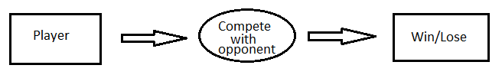

**Figure No***.* **1**

This will require a player to compete with its opponent to win the race. Only 2 possibilities have Win/Lose. The winner will give a reward and the loser will be punished by consuming their RP points.

## 8.1 Hardware Interfaces

Android devices are required to operate the whole system. No other devices are used to run this game.it is only an android game. There will be more than 1GB ram in the mobile. The storage required is more than 50Mb only. No external hardware is used in this game. It will only be performed by the android devices.

## 8.2 Software Interfaces

The software interface is very simple in this game. Because everyone can understand. Android operating system (version marshmallow) is required to run the third game. Other versions will not be able to run this game. The google play game will save the data/profile of the player later on it will use his, her own data. The permissions which require is that to access the (storage, location, id, etc.). There are no background services run in this game. The data of every person is saved, it will not be shared to the other people, only their (results, level, profile) picture shown to the other people.

# 9.Functional Requirements

These are the functional requirements of our software which is defined under the following.

## 9.1 User/Player profile ()

In this functional requirement we can use the player profile in which He, she creates his profile to enter in the game.

## 9.2 Joining room with another player ()

In this the user can enter the room using the notifications that come on the screen that the other players will send a match reservation to play a game with you. Another way to join a room is toplay in the main display panels to select rooms or create rooms or join rooms.

## 9.3 Single/multiplayer room ()

In the user can play single match play r multiplayer play using the options in the display panel

## 9.4 Select character like (Male, Female) ()

The user can select the character to play the game and it will also make a detailed view of the player.

## 9.5 Player Inventory System ()

In this section it will give the overview of the player inventory to store the clothes, cars etc.

## 9.6 Select vehicle like (Cars, Trucks, Buses etc.) ()

In this section the player has the ability to select the vehicles which are open or bought from the cars inventory system as they desire.

## 9.7 Defeat others with strategy ()

In this system the player can defeat the other player to select the different strategy to win the game in the multi r single player game.

## 9.8 Compete opponent ()

In this section the player can compete with another player to win the race**.**

## 9.9 Win/Lose ()

There are two possibilities win or lose

## 9.10 Rewards ()

In this we will manage the rewards about the player which wins the game. It will give R.P points to the player on the different strategies.

RP points will be given to the player when they complete one stage and move to the next.

In multiplayer mode, the winning player will get RP points.

# 10.Non-functional Requirements

## 10.1 Performance Requirements

Project performance is proper working of application with efficiency and accuracy. Quick responses of the game and quick movements on End state with going on halt position.

*.*

## 10.2 Safety Requirements

There are no harmful things in the system.

*.*

## 10.3 Security Requirements

Not high security required for the system

## 10.4 User Documentation

User manual is provided along with the application in the form of instruction to the player.

# 11.Use Case Diagram

The purpose of the use case diagram is to capture the dynamic aspect of a system.

|  |  |  |  |  |
| --- | --- | --- | --- | --- |
| **<Use case Id: Make profile>** | | | | |
| **Actors:**  *User* | | | | |
| **Feature:** *It will create a user profile and save it for future use* | | | | |
| **Use case Id:** | | *1* | | |
| **Pre-condition:** | | *User must be a 12years old* | | |
| **Scenarios** | | | | |
| **Step#** | **Action** | | | **Software Reaction** |
| **1.** | *User enter his details* | | | *System will create his profile* |
| **2.** |  | | |  |
|  |  | | |  |
| **Alternate Scenarios:** *Write additional, optional, branching or iterative steps. Refer to specific action number to ensure understandability.* | | | | |
| **1a:**  **2a:** | | | | |
| **Post Conditions** *None* | | | | |
| **Step#** | **Description** | | | |
|  | *Allows the Player to create a profile and play the game*. | | | |
|  |  | | | |
|  |  | | | |
| **Use Case Cross referenced** | | | *<Related use cases, which use or are used by this use case>* | |
| **User Interface reference** | | | *User will be redirected to main menu* | |
| **Concurrency and Response** *Give an estimate of the following*   * *One/many users will use the game at a time* | | | | |

|  |  |  |  |  |
| --- | --- | --- | --- | --- |
| **<Use case Id: Main Menu>** | | | | |
| **Actors:**  *user* | | | | |
| **Feature:** *It displays the game panel which shows all the maps room etc.* | | | | |
| **Use case Id:** | | *2.* | | |
| **Pre-condition:** | | *User profile* | | |
| **Scenarios** | | | | |
| **Step#** | **Action** | | | **Software Reaction** |
| **1.** | *Enter the detail about account.* | | | *A Game screen is shown.* |
| **2.** |  | | |  |
|  |  | | |  |
| **Alternate Scenarios:** *Write additional, optional, branching or iterative steps. Refer to specific action number to ensure understandability.* | | | | |
| **1a:**  **2a:** | | | | |
| **Post Conditions** *None* | | | | |
| **Step#** | **Description** | | | |
|  | *Allows the Player to Quit the game or play* | | | |
|  |  | | | |
| **Use Case Cross referenced** | | | *<Related use cases, which use or are used by this use case>* | |
| **User Interface reference** | | | *List user interface(s) that are related to this use case. Use numbered list in case of more than one user interface elements.* | |
| **Concurrency and Response** *Give an estimate of the following*   * *Number of concurrent users* * *Expected response time of the use case* | | | | |

|  |  |  |  |  |
| --- | --- | --- | --- | --- |
| **<Use case Id: Join Room>** | | | | |
| **Actors:**  *User* | | | | |
| **Feature:** *Enter the room and play the game* | | | | |
| **Use case Id:** | | *3* | | |
| **Pre-condition:** | | *Having some BP r code* | | |
| **Scenarios** | | | | |
| **Step#** | **Action** | | | **Software Reaction** |
| **1.** | *It will create a room r you code to enter in the room* | | | *It will join room* |
| **2.** |  | | |  |
|  |  | | |  |
| **Alternate Scenarios:** *Write additional, optional, branching or iterative steps. Refer to specific action number to ensure understandability.* | | | | |
| **1a:**  **2a:** | | | | |
| **Post Conditions** *None* | | | | |
| **Step#** | **Description** | | | |
|  | *The Player first checks that any player is active in the room for the game, then joins the room to play the game.* | | | |
|  |  | | | |
|  |  | | | |
| **Use Case Cross referenced** | | | *<Related use cases, which use or are used by this use case>* | |
| **User Interface reference** | | | *User will be redirected to main menu* | |
| **Concurrency and Response** *Give an estimate of the following*   * *One/many users will use the game at a time* | | | | |

|  |  |  |  |  |
| --- | --- | --- | --- | --- |
| **<Use case Id: Game Start>** | | | | |
| **Actors:**  *user* | | | | |
| **Feature:** *The Game Will start according to their button they press* | | | | |
| **Use case Id:** | | *4* | | |
| **Pre-condition:** | | *Select the vehicle* | | |
| **Scenarios** | | | | |
| **Step#** | **Action** | | | **Software Reaction** |
| **1.** | *Click on the start button* | | | *Game us will display* |
| **2.** |  | | |  |
|  |  | | |  |
| **Alternate Scenarios:** *Write additional, optional, branching or iterative steps. Refer to specific action number to ensure understandability.* | | | | |
| **1a:**  **2a:** | | | | |
| **Post Conditions** Profile chosen | | | | |
| **Step#** | **Description** | | | |
|  | *The Player join the room and game is start between players* | | | |
|  |  | | | |
| **Use Case Cross referenced** | | | *<Related use cases, which use or are used by this use case>* | |
| **User Interface reference** | | | *List user interface(s) that are related to this use case. Use numbered list in case of more than one user interface elements.* | |
| **Concurrency and Response** *Give an estimate of the following*   * *Number of concurrent users* * *Expected response time of the use case* | | | | |

|  |  |  |  |  |
| --- | --- | --- | --- | --- |
| **<Use case Id: Compete others>** | | | | |
| **Actors:**  *user* | | | | |
| **Feature:** *Players are competing the opponent and win with the strategy* | | | | |
| **Use case Id:** | | *5* | | |
| **Pre-condition:** | | *With strategies and boosting* | | |
| **Scenarios** | | | | |
| **Step#** | **Action** | | | **Software Reaction** |
| **1.** | *Use the acceleration buttons focus in the herd plus etc.* | | | *Games panel shown* |
| **2.** |  | | |  |
|  |  | | |  |
| **Alternate Scenarios:** *Write additional, optional, branching or iterative steps. Refer to specific action number to ensure understandability.* | | | | |
| **1a:**  **2a:** | | | | |
| **Post Conditions** *Multiplayer chosen* | | | | |
| **Step#** | **Description** | | | |
|  | *Player can perform a good or bad experience* | | | |
|  |  | | | |
| **Use Case Cross referenced** | | | *<Related use cases, which use or are used by this use case>* | |
| **User Interface reference** | | | *List user interface(s) that are related to this use case. Use numbered list in case of more than one user interface elements.* | |
| **Concurrency and Response** *Give an estimate of the following*   * *Number of concurrent users* * *Expected response time of the use case* | | | | |

|  |  |  |  |  |
| --- | --- | --- | --- | --- |
| **<Use case Id: Result Win/lose>** | | | | |
| **Actors:**  *user* | | | | |
| **Feature:** *When the player competes their opponent and win or lose with the strategy,*  *You lose or you win panel is shown.* | | | | |
| **Use case Id:** | | *6* | | |
| **Pre-condition:** | | *Play the overall game* | | |
| **Scenarios** | | | | |
| **Step#** | **Action** | | | **Software Reaction** |
| **1.** | *Play The Game.* | | | *Player win/ Lose.* |
| **2.** |  | | |  |
|  |  | | |  |
| **Alternate Scenarios:** *Write additional, optional, branching or iterative steps. Refer to specific action number to ensure understandability.* | | | | |
| **1a:**  **2a:** | | | | |
| **Post Conditions** *Compete with others* | | | | |
| **Step#** | **Description** | | | |
|  |  | | | |
|  |  | | | |
| **Use Case Cross referenced** | | | *<Related use cases, which use or are used by this use case>* | |
| **User Interface reference** | | | *List user interface(s) that are related to this use case. Use numbered list in case of more than one user interface elements.* | |
| **Concurrency and Response** *Give an estimate of the following*   * *Number of concurrent users* * *Expected response time of the use case* | | | | |

|  |  |  |  |  |
| --- | --- | --- | --- | --- |
| **<Use case Id: Reward/Punishment >** | | | | |
| **Actors:**  *user* | | | | |
| **Feature:** *Gives the reward to the player r punish in the bp/Rp decrease* | | | | |
| **Use case Id:** | | *7* | | |
| **Pre-condition:** | | *Play whole game don't exit the game* | | |
| **Scenarios** | | | | |
| **Step#** | **Action** | | | **Software Reaction** |
| **1.** | *None* | | | *Panel is shown about it.* |
| **2.** |  | | |  |
|  |  | | |  |
| **Alternate Scenarios:** *Write additional, optional, branching or iterative steps. Refer to specific action number to ensure understandability.* | | | | |
| **1a:**  **2a:** | | | | |
| **Post Conditions** *Win/Lose* | | | | |
| **Step#** | **Description** | | | |
|  | *When the player wins the game, the player is rewarded with the coins and the winner punishes the loser.*  *When the player loses the game, punishment given to that player by their ranks decrease in points.* | | | |
|  |  | | | |
| **Use Case Cross referenced** | | | *<Related use cases, which use or are used by this use case>* | |
| **User Interface reference** | | | *List user interface(s) that are related to this use case. Use numbered list in case of more than one user interface elements.* | |
| **Concurrency and Response** *Give an estimate of the following*   * *Number of concurrent users* * *Expected response time of the use case* | | | | |

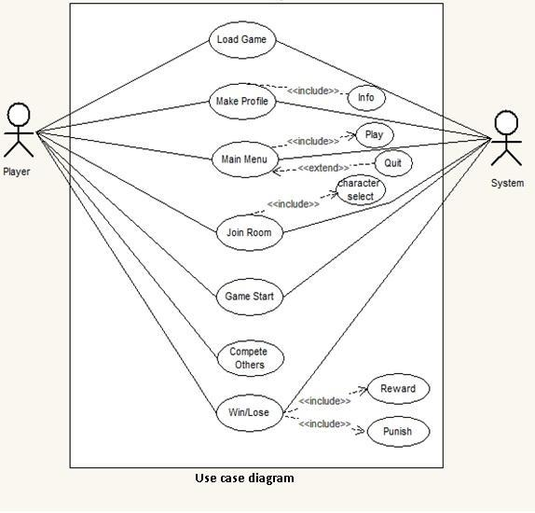

Figure Use case Diagram

# 12.Design Considerations

The design considerations involve the different Accessibility, Color, Culture, Functions, Health and safety, Human Factors, Layout, Language etc. It’s important to involve your team and other key stakeholders in project design. This will help ensure important details are included, and that your project is realistic and achievable. Our project design should be carefully documented, and a variety of visual aids may be incorporated, as well. The design consideration involves the different things such that the language in this game we used is English. There are some functions involves in the game. There are different layers of the colors.

## 12.1 Assumptions and Dependencies

In this game the user profile is required for the backup of the data. First the payer can enter the data. The Game Logic Module generates all the motion control signals of all the objects in this game according to various algorithms. The game will start with a profile of the user and run like lobby profile where he chooses the maps or to choose play parking r racing with other players etc.

## 12.2 Risks and Volatile Areas

The game has different levels which has different ways(strategies) to achieve. The player’s goal is to get to the destination as soon as possible while trying to avoid bumping to other cars or road object, the final score will be posted according to the finishing position, numbers of bumps and the time.

# 13.System Architecture

In this the game is running in the mobile devices which is running up to lollipop version. It will require the minimum 1GB ram in the device.

## 13.1 System Level Architecture

The theme of our game is to compete with the other opponents that are controlled by computer in a racing tournament, the player’s goal is to get to the destination as soon as possible while trying to avoid bumping to other cars or road object, the final score will be posted according to the finishing position, numbers of bumps and the time.

To implement the action of moving forward, we first make the end of the road at the center of the screen to make sure the player’s focus is on the road. Then we create stripes of two different patterns, one is light and the other is dark. We keep switching positions of two kinds of stripes to generate the effect of moving the road.

We use the up arrow on the keyboard/screen to speed up. When the up arrow is pressed, we raise the switching frequency to make the road move faster. When the player’s car hits the back of another racing car, it slows down and we lower the switching frequency. When the player’s car passes another car, we simply move the car that gets passed from its current position down to the bottom of the screen and then disappear. By moving the car, we will also keep scaling the car.

The similar algorithm applies when the player’s car gets passed; we just move the passing car Change direction We use the left and right key to control the left and right movement of the player's car/we also use the gyroscope movement. We will keep track of the position of the car. When the left or right key is pressed, we move the position of the car to the left or right lane and draw the car based on the position.

## 13.2 Sub-System / Component / Module Level Architecture

The system level is described under with the help of diagrams.

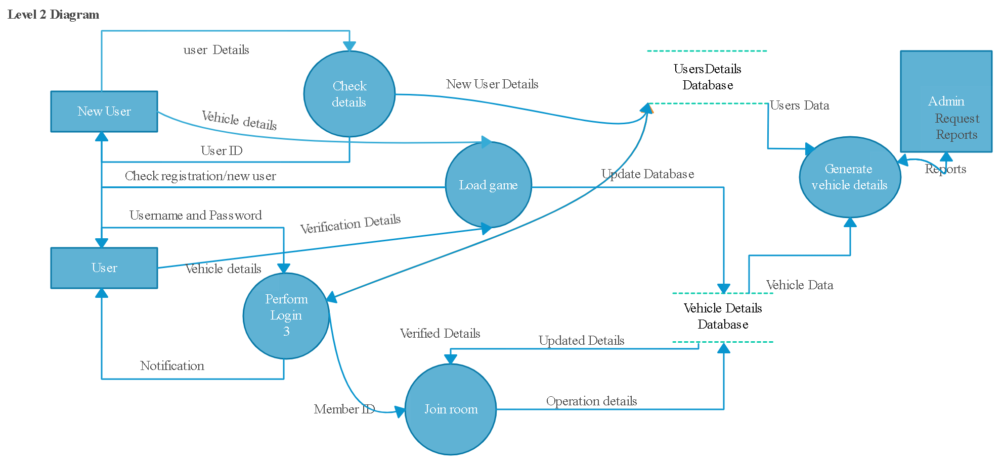

Figure System Architecture Diagram

## 13.3 Component / Sub-Module Level Architecture (1…n)

Identify all the sub components or sub modules (if any) of the already identified modules and components. Provide their diagrammatic view using appropriate detailed architecture diagrams presenting how those subsystems, modules and components are further divided into sub components and sub modules and how they interact with each other*.*

# 14.Design Strategies

Every new user is need to make profile and the enter into the game the guest mode will also work*.*

## 14.1 Load game

The game will load on the software r mobile app.

## 14.2 Make profile

The user can make the profile and enter the data into the given fields.

## 14.3 Join room/parking system

The player has the ability to choose the parking or joining room with the button options present in it.

## 14.4 Game start

The game will start after the user can click the start button

## 14.5 Compete with opponent

The player then competes with other players in the game to win the game. If they choose a parking system then it will be careful to cross the hurdles in the map.

## 14.6 Win/Lose

At the end the player who wins or loses the panel is shown.

# 15.Detailed System Design

## 15.1 Class diagram:

The class diagram is the main building block of object-oriented modeling. It is used for general conceptual modeling of the structure of the application, and for detailed modeling translating the models into programming code. The class diagram will show the main process of the project.

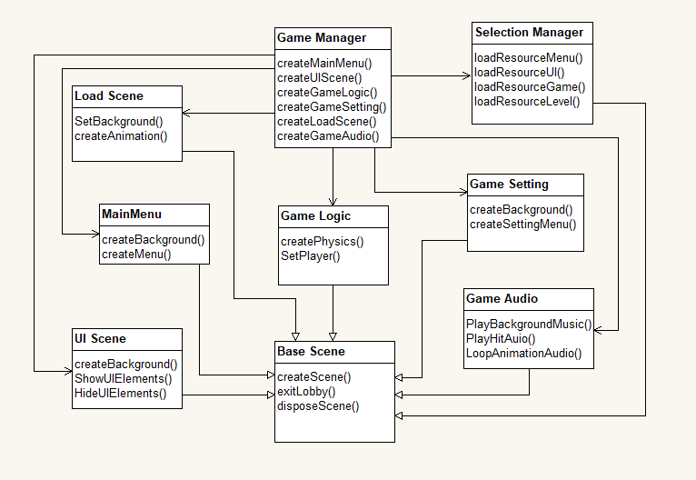

Figure Class Diagram

## 15.2 Collaboration Diagram

A collaboration diagram, also known as a communication diagram, is an illustration of the relationships and interactions among software objects in the Unified Modeling Language (UML). These diagrams can be used to portray the dynamic behavior of a particular use case and define the role of each object. Normally an actor instance occurs in the collaboration diagram, as the invoker of the interaction. An object is represented by an object symbol showing the name of the object and its class underlined, separated by a colon:

Objectname : classname

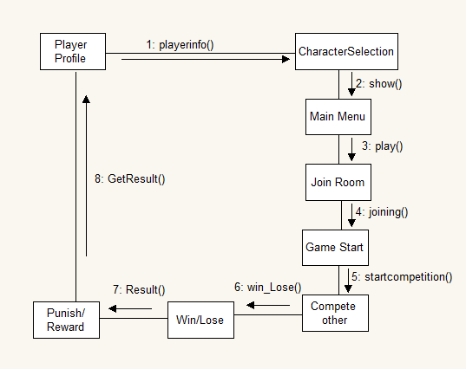

Figure System Collaboration Diagram

## 15.3 Entity Relationship Diagram (ERD)

An entity–relationship model describes interrelated things of interest in a specific domain of knowledge. A basic ER model is composed of entity types and specifies relationships that can exist between entities. An ERD contains different symbols and connectors that visualize two important information: The major entities within the system scope, and the inter-relationships among these entities.

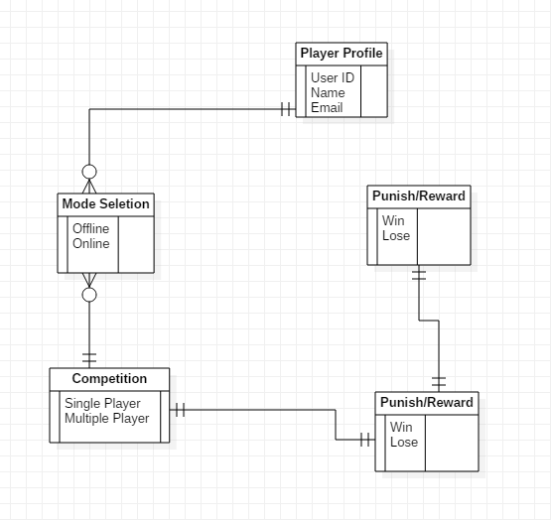

Figure Entity Relationship Diagram

## 15.4 Activity Diagram

An activity diagram is a behavioral diagram i.e., it depicts the behavior of a system. An activity diagram portrays the control flow from a start point to a finish point showing the various decision paths that exist while the activity is being executed. Activity diagrams are graphical representations of workflows of stepwise activities and actions with support for choice, iteration and concurrency.

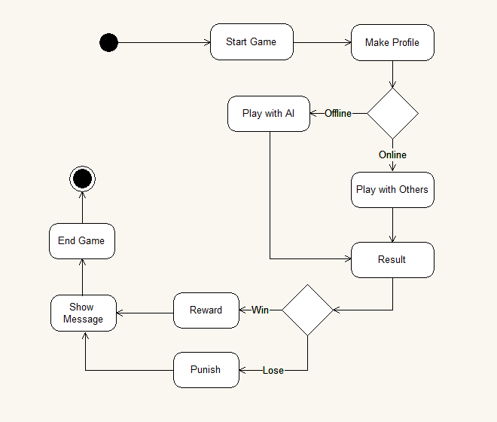

Figure Activity Diagram

## 15.5 Sequence Diagram

A sequence diagram simply depicts interaction between objects in a sequential order i.e., the order in which these interactions take place. We can also use the terms event diagrams or event scenarios to refer to a sequence diagram. Sequence diagrams describe how and in what order the objects in a system function. It depicts the objects involved in the scenario and the sequence of messages exchanged between the objects needed to carry out the functionality of the scenario.

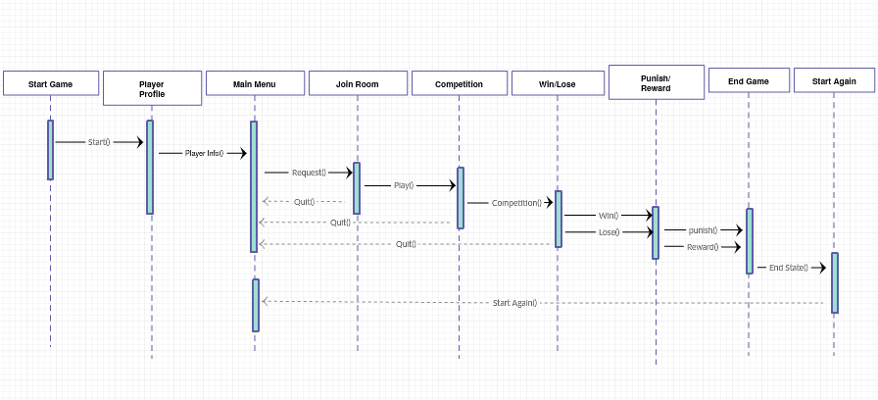

Figure Sequence Diagram

# 16.References

This section should provide a complete list of all documents referenced at a specific point in time. Each document should be identified by title, report number (if applicable), date, and publishing organization. Specify the sources from which the references can be obtained (This section is like the bibliography in a published book).

|  |  |  |  |
| --- | --- | --- | --- |
| **Ref. No.** | **Document Title** | **Date of Release/ Publication** | **Document Source** |
| 1 | Project Proposal | Jan 25, 2022 | https://docs.google.com/document/d/16VBA8WBp-2iFsdYGM9HANJXvJ6IrIs6C/edit?usp=sharing&ouid=116915159730958749798&rtpof=true&sd=true |
| 2 | SRS | Jan 25, 2022 | https://docs.google.com/document/d/1IW_tUjhyGYaXb03AbM-QzOlyfIOtSjVY/edit?usp=sharing&ouid=116915159730958749798&rtpof=true&sd=true |
|  |  |  |  |
|  |  |  |  |
|  |  |  |  |
|  |  |  |  |
|  |  |  |  |
|  |  |  |  |
|  |  |  |  |